Creating your Tapestry parent account

Step 1 – Shortly after you have provided us with your details, you will receive an email asking to create your St Thomas More Catholic Voluntary Academy login.
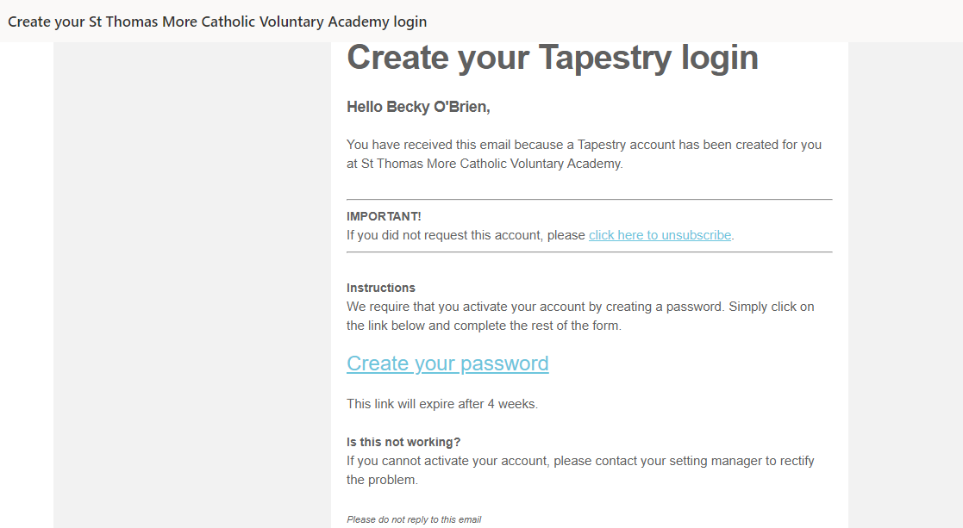

Step 2 – Create a password and a 4 digit pin.
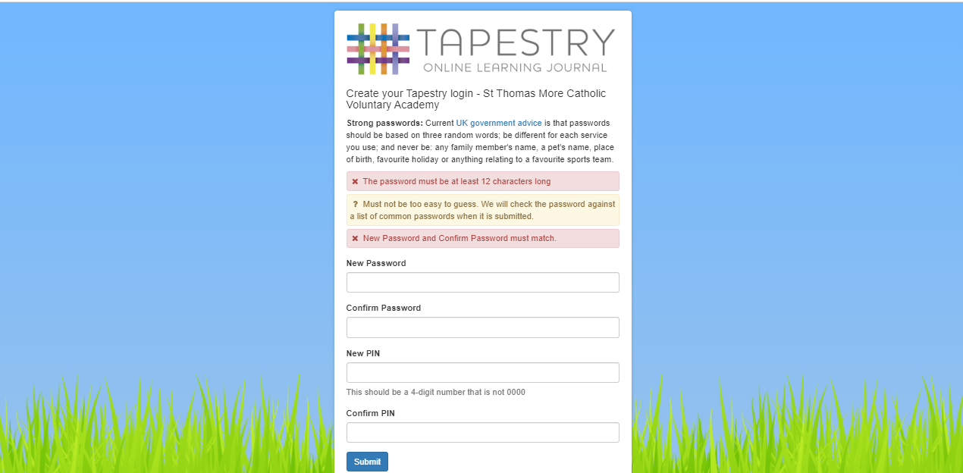

Step 3 – Once you have created a password you will be taken to your home page which will look similar to the screen shared below. You will now need to fill in your child’s ‘All About Me’ information. This will allow you to share any important information about your child which allow us to help your child settle into their new classes.

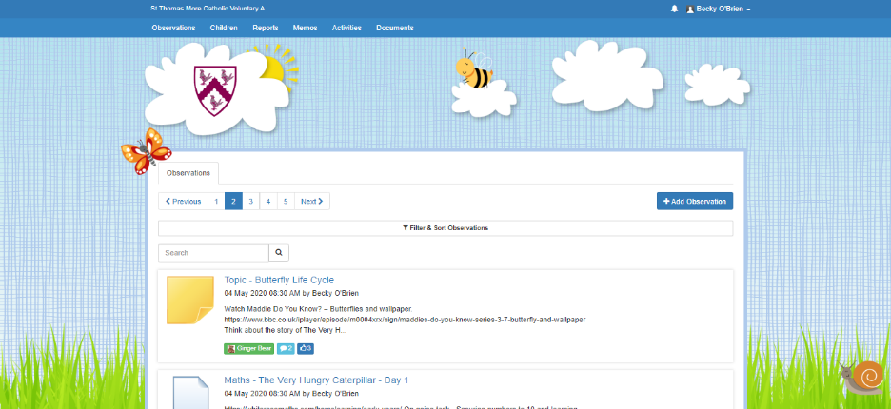
You can do this by selecting children

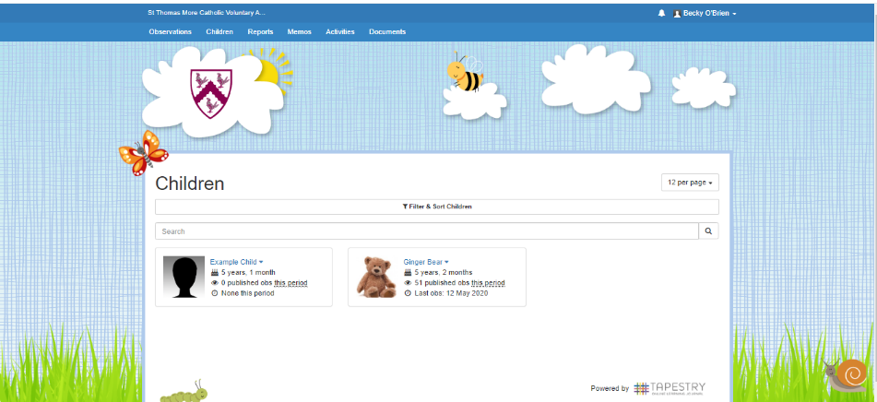
Selecting your child’s name

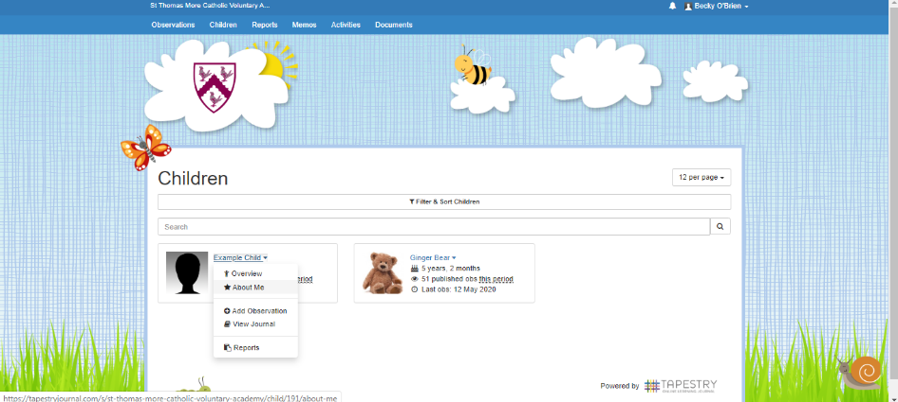
Select ‘About me’

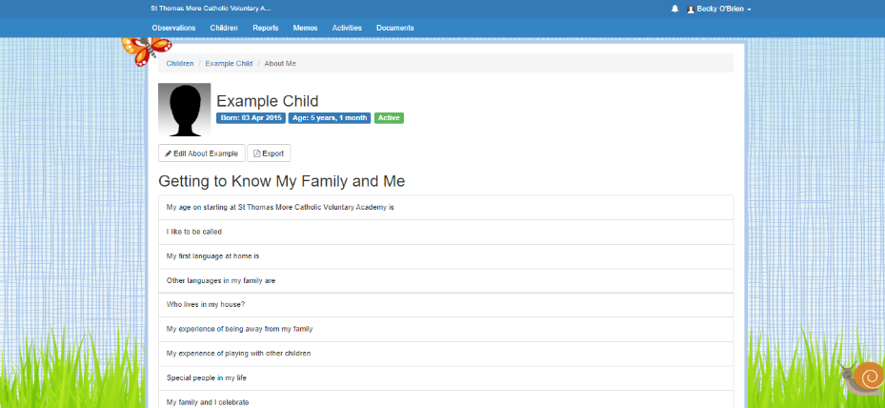
Select ‘Edit About (child’s name)’

Once you have completed the form
select save at the bottom.

Adding an observation

Step 1 – Select ‘Add Observation’ at the top of the page.
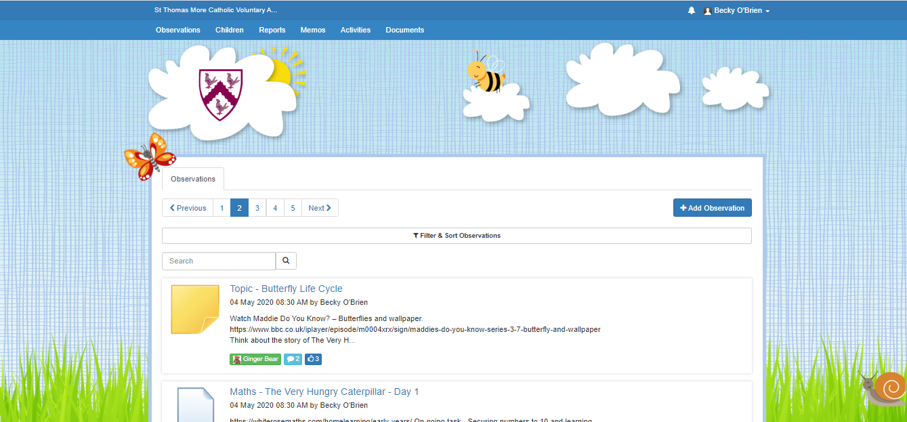

Step 2 – Select your child’s name, add a title and any notes you wish to include.
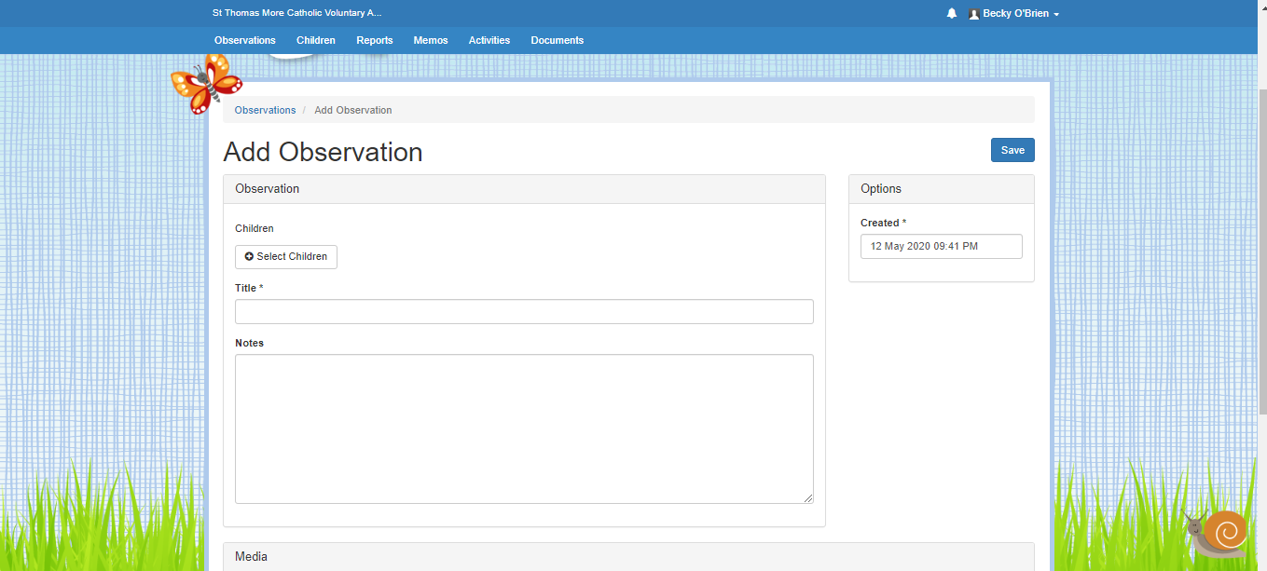
Step 3 – You can add a photo or video by selecting ‘Add Files’, selecting your document and finally ‘Start Upload’. If you are using the app you will need to complete steps 1 and 2 initially before choosing one of the following options – ‘Take Picture’, ‘Record Video’ or ‘Add From Library’. Once you are happy with your observation you can select save.
