St Thomas More Catholic Voluntary Academy
Religious Education Policy

Agreed by the Governing Body  November 2020 | 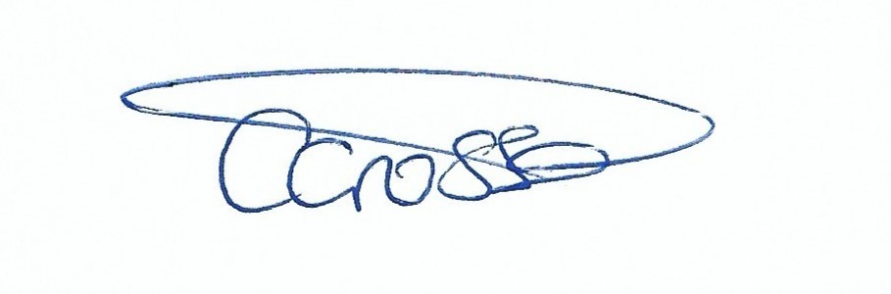  Mrs. Charlotte Crosse Headteacher | 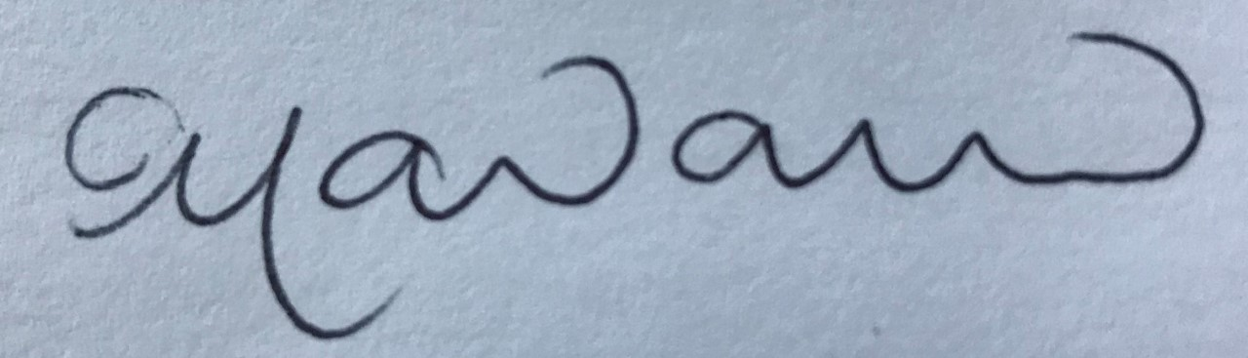  Dr. Claire Macdonald  Chair of Governors
Review Date: November 2022

Mission Statement
Saint Thomas More Catholic Voluntary Academy was founded to pass on to the children the faith heritage of the local Catholic Community. Each child is valued as a unique individual, a child of God, made in the image of Father, Son and Holy Spirit. In partnership with parents and parish and with God's grace, the school tries to discern and help the child to develop fully as a person with particular gifts and aptitudes. Guided and challenged by Gospel values, the school aims to provide a community in which the child will grow and experience the love of God, self and neighbour.

"LOVE ONE ANOTHER AS I HAVE LOVED YOU"
John Chapter 13 Verse 34

Aims of Religious Education
St Thomas More Catholic Voluntary Academy acknowledges that Religious Education is a lifelong process and recognises that the primary years are significant in the lasting impression they make upon our children.

Religious Education in school is concerned with children understanding
mankind’s search for meaning, value and purpose in life. The religions of the world are classic expressions of this search and, for many people, provide the context within which the experience is to be understood. Through his or her understanding of this search, the child is helped towards a deeper awareness of their identity enabling him/her to grow and develop freely in a world of divergent beliefs and values.

Education is concerned with the development of understanding. Religious Education is concerned with the development of the understanding of religion as a significant area of human experience. ‘Understanding’ is used in a wide sense, being concerned with feeling and empathetic insight as well as an intellectual grasp of certain information. The child is not simply learning about religion, they are learning from it.

The Religious Education Programme
To fulfil our aims, we use the Come and See programme of Religious Education. In accordance with the guidelines from the Bishops' Conference. The children at St Thomas More receive 2.5 hours of Religious Education each week. It integrates the Catechism of the Catholic Church, the Catholic Levels of Attainment and the Religious Education Curriculum Directory. Children explore the mystery of Faith through Scripture and Tradition. Links are made explicitly in planning documents to the resources and plans are adapted to meet the needs of the unique cohort. Lessons are very well resourced with both interactive stimuli, a variety of artefacts and making cross curricular links.
There are three topics taught each term and 2 ‘other faith’ units; Islam, Hinduism or Sikhism and Judaism. Come and See meets the requirements of the Curriculum Directory.

There is a selection of ritual objects, books, videos and posters in school. Children will have the opportunity to visit a Synagogue, a Mosque, a Gurdwara, and a Mandir during their school career at St Thomas More.
Planning
Taking a whole school approach in using Come and See, we are confident that the breadth of the curriculum is being taught and that there is good progression from year to year. There is a planning proforma for staff to use for each topic. Please refer to the Come and See materials for more detail about planning and curriculum coverage.
The advantages of this approach are:
• appropriate content for each group is ensured
• planning and recording are easy
• continuity and progression across the school are assured
• communal celebrations are possible
Assessment and Record Keeping
Each teacher has the responsibility for maintaining records for the children in
their class. Detailed assessment is carried out through an Assessment Task three times a year focusing on a rolling programme of standards
Assessments are regularly moderated through staff meetings, Trust Meetings and at Diocesan level with other RE Coordinators in the Nottingham Diocese. Regular advice from David Quinn the Diocesan Education Advisor is sought to assist with moderation. Assessments are entered by class teachers onto Target Tracker after each Assessment Task. The subject leader then analyses attainment and progress at whole class and group level. This includes the monitoring of vulnerable groups. This information is then used to inform action planning. RE is reported formally to parents in the annual reports.

Home, School, Parish links
We recognise the importance of parents as the child's first teacher and their role in faith development. Parents and staff do everything possible to work in close partnership. There are many opportunities for parents to engage in school life.
St Thomas More Catholic Voluntary Academy seeks, in partnership with parents and parish, to develop and nurture the Catholic faith of our children. We strive to bring pupils to a fuller understanding and knowledge of the Roman Catholic tradition.
On Holy Days of Obligation (where circumstances permit) the staff and pupils of St Thomas More Catholic Voluntary Academy will celebrate Mass in the parish church. Key Stage 2 children regularly lead 9am Sunday Mass in the Parish Church of St Thomas More. Children in Key Stage 1 and 2 attend parish masses on a weekly rota. Children in F2 and Key Stage 1 prepare and lead class liturgical services to which parents and members of the parish are invited.
Children are prepared for Holy Communion at the parish church of St Thomas More.
Christmas and Easter celebrations take place in the church in consultation with the parish.
Our Friends of St Thomas More are a group of parents and carers who give generously of their time and raise sums of money for the good of our children.

Our Statements to Live By are shared with parents through newsletters.

Parents are:
- given a warm welcome when they visit our school.
- given termly curriculum overviews which inform them of the topics covered in class, as well as ways they can support their child's learning. This includes the Statements to Live By.
- given an opportunity to give support/input with their child's RE homework.
- given regular newsletters.
- given a verbal report on their child's RE development during Parents Evenings.
- given a written report on their child's RE development at the end of the year.
- given opportunities to be involved in all charity activities during the year for school or for the wider community.

Monitoring and Evaluation
The school’s provision of Religious Education and Collective Worship and the Catholic Life of the School will be evaluated regularly though observation, parent, pupil and staff surveys and feedback will be analysed to consider whether it meets the needs of all pupils, parents and staff.

The Religious Education Subject Leader
The first purpose of the RE subject leader’s role is to help improve the quality of the teaching and learning that the pupils receive in Religious Education.
The subject leader is responsible for:
- writing and keeping relevant documentation up to date
- co-ordinating the teaching throughout the school by encouraging collaboration between year groups or key stages
- being involved in the process of assessment, recording and reporting
- monitoring the quality of teaching, the progression and continuity of Religious Education throughout the school.
- offering support and advice to colleagues
- identifying resource requirements
- maintaining a strong relationship between the school and the Diocese, and with the school’s Diocesan advisor
- maintaining the high status of worship within the school
- with the headteacher, completing the Religious Education action plan and using it to inform the School Improvement Plan
- keeping resources well stored, catalogued and available.
- ensuring that the Curriculum Directory is understood and being followed.

Environment and Display
From the moment you enter St Thomas More Catholic Voluntary Academy, the school environment clearly illustrates that we are a Catholic school. Our School Mission statement and the current Statement to Live By are clearly displayed in our entrance hall and in all classrooms. Each classroom has a prayer area in a prominent place of the classroom and a display dedicated to current learning in Religious Education. Around the school, there are an everchanging number of displays showing the children’s religious written work and art work, statues of saints and The Holy Family, school fundraising endeavours, links with the parish community and prayer areas. The Bishop’s themes of Encounter, Discipleship and Missionary Discipleship are developed and worked towards during the school year.

Resources
Each class has an RE Prayer box with objects and fabrics suitable for all seasons of
the liturgical year.
Each class has a set of resources to support child-led worship - Let Us Pray.
RE resources are stored in the room adjoining the Resource room and outside the F2/Y1 classroom. Each class has Come and See planning resources and online access to the bank of interactive resources.
An online version of the Wednesday Word is published weekly on the school website homepage.

Prayer Areas
Each class has an area for prayer focus, which is in an area all children can see when they pray. The theme of the prayer focus should relate to the season of the liturgical year. The holy area should feature a cloth reflecting the liturgical year or a feast day and some ritual objects. Cloths for the holy areas in each class reflecting the liturgical year are kept in each class.
Ritual objects may include pictures, icons, stones, bibles, flowers, bark, holy water, rosary, seashells or candles.
Cloths and ritual objects are stored in each classroom in the Prayer Box and are the responsibility of the class teacher.
The NDCYS Extra-ordo-nary calendar is displayed in each classroom. Changed weekly and consulted daily to note changes of liturgical colour and Saints’ days and Solemnities.

RE Display Boards
Each class has a Come and See display board which has the current theme displayed. There will be examples of children’s work relevant to the current theme displayed. The relevant driver words under Attainment Targets 1, 2 and 3 will be displayed as well as the Big Question for each topic. The I Can Statements are displayed and shared with the children at the start of a new topic.

Prayer Diaries
Each child from Year 2 upwards has their own Prayer Diary in which to record personal reflections and time is allowed for children to use these regularly.

Let Us Pray
Each child, in every class, will have a regular opportunity to lead their class in Collective Worship using the Let Us Pray resources. Let Us Pray will take place in each class at least once a week

Wider Community
We at St Thomas More Catholic Voluntary Academy encourage involvement with the community. At the heart of a vibrant and caring community, St Thomas More Catholic Voluntary Academy's close network of local partners help to drive exceptional outcomes for children. Partners are also invited to our special events such as Masses, services, assemblies, the Christmas nativities, the carol service, Easter and summer concerts. Across the curriculum, we aim to deliver full engagement and learning for each child. As well as promoting cohesion, community and partner engagement enhances our children’s progress, resilience and resourcefulness by facilitating:
- a curriculum that is constantly challenging and innovative;
- a richer school environment;
- direct mentoring support;
- a range of encounters with possible professions;
- a learning culture giving the freedom to experience, experiment and discover.

Spiritual, Moral and Social Education
The Come and See programme encourages the children to think about their
relationships and act responsibly. Year 5 and 6 children take on specific the roles and responsibilities within our school to develop their sense of community including helping with younger children at play times, reading with partners to improve confidence and fluency and performing regular housekeeping duties to support the
school family. Our behaviour policy is founded on the principles of restorative justice.

Equal opportunities
Religious Education cannot proceed on the assumption that all pupils will, or
should, have positive religious convictions or commitments. St Thomas More Catholic Voluntary Academy should however, foster the search for meaning, value and purpose since these are implied by the very concern to educate the whole person. It is therefore a legitimate part of the pupil's education that he/she should be
encouraged to consider his/her own response to such issues.

Marking and Presentation
Work should be marked in accordance with the school marking policy (see policy). Work should be marked with reference to the learning intentions, which themselves include the Driver words. Key words must be corrected. Comments should encourage children to reflect, analyse and should be interactive. The use of the heart symbol for AT2 and the cloud symbol for AT3 is encouraged. RE books are distinctive in appearance to reflect their special importance at our school. Pupils show pride in their religious education books and presentation in them reflects this. RE topics are marked in the RE Books by a topic label which includes the Big Question. This question is answered by the child at the beginning of the topic. RE topics conclude with a respond page which include the I Can Statements. The statements are reflected on by the children in relation to the work they have completed during the topic and comment is made by the child (scribed for KS1) after reflection on their own learning.

November 2020

