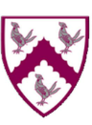
Implementations of Science Lessons at St Thomas More
What would we expect to see in Science lessons in the school?
- Children working on objectives in line with the curriculum intent for Science (as published on the school website).
- Current lesson is placed within sequence of learning within the unit.
- Each lesson begins with a short ‘remembering more’ section: Flashback (questions from previous learning within the current topic/similar topics from previous years).
- Topic-specific vocabulary are clearly explained and revisited within the correct context during the lesson.
- Teaching of science will take the form of some direct instruction.
- Children will be taught substantive scientific knowledge (content) first, before they undertake enquiry.
- Children will be taught disciplinary knowledge (scientific enquiry skills - ‘how was the knowledge established?’) relevant to their key stage.
- Tasks directly relate to the learning intentions. All children are working towards meeting the same learning intentions. They are supported and/or challenged appropriately. Some children might be working below the year group and be taught a separate curriculum.
- Talk task and plenaries - regular review of children's understanding through discussions, questioning and quizzes.
- Quizzes and assessment tasks are used at the beginning and end of topics.

A skeleton outline of a St Thomas More Science Lesson:
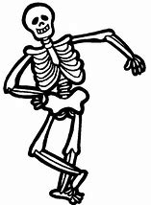
Prior Learning
Vocabulary focus: introduction of new vocabulary that will be used in the lesson.
Teaching input
Talk Task – retrieval and understanding.
Task – All children working towards the same learning intentions (substantive and disciplinary knowledge)
Plenary – retrieval and understanding.

