St Thomas More Catholic Voluntary Academy
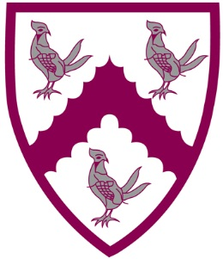
Parental Questionnaire
June 2019
Religious Education (49 Responses)

Religious Education should be central to the curriculum in a Catholic school. It teaches about the faith in the context of a school which proclaims the Gospel.

We are interested in your views on the following.
Please tick the box that you feel most appropriate | AGREE | DISAGREE | DON’T  KNOW
My child enjoys Religious Education | 98% | 2% | -
I am happy with the Come and See RE curriculum | 80% | 4% | 16%
I am satisfied with my child’s standard of work in RE | 92% | 4% | 4%
The school keeps me informed about my child’s progress in RE | 90% | 6% | 4%
The school keeps me informed about what my child is studying in RE | 82% | 12% | 6%
The work my child does in RE enables them to think spiritually, ethically and theologically | 92% | - | 8%
RE is well led | 96% | - | 4%

