Advent 1
Themes/Interests/  Lines of Enquiry |  | Teddy Bears Pete the Cat Family Feelings  (School values/rules)  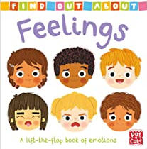
Suggested Texts | Baseline & Transition Themed Books | 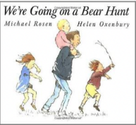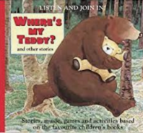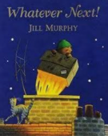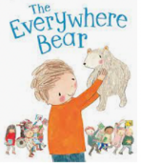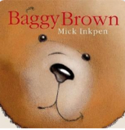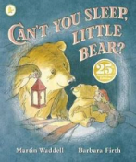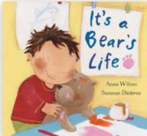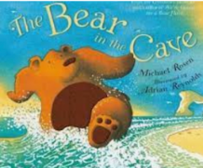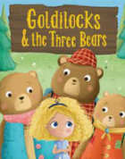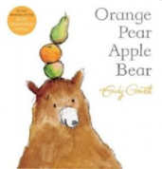
Child led interests covered during the half term:

Prime Areas

Area of learning |  | Objectives/skills | Revisit/ongoing  throughout the year
Communication and Language |  | Listening:  Listen to others 1:1, in small groups and whole class.  Enjoy listening to stories and can remember what happens.  Listen carefully to rhymes and songs, paying attention to how they sound.  Understand how to listen carefully and why listening is important.  Attention:  Maintain attention in whole class and small group contexts for a short time.  May find it difficult to pay attention to more than one thing at a time.  Respond:  Engage in story times.  Join in with repeated refrains and anticipate key events and phases in stories or rhymes.  Respond appropriately when asked.  Understanding:  Follow 1 step instructions e.g., put bookbag in drawer.  Speaking:  Use sentences of 4-6 words.  Sing a large repertoire of songs e.g., nursery rhymes or numbers of songs.  Begin to use social phrases e.g., ‘Good Morning! | Learn new vocabulary Use new vocabulary in different contexts.  Use new vocabulary through the day in discussions and conversations.  Learn new rhymes, poems, and songs.  Listen to and talk about stories to build familiarity and understanding.  Use talk to organise themselves and their play.
Personal, Social  and Emotional Development |  | Express feelings:  Know that all feelings are ok. Know how to recognise own feelings, talk about feelings using words like ‘happy’, ‘sad’, ‘angry’.  Begin to understand how others might be feeling.  Know they can rely on their teachers, friends, and ‘buddy’ for support if they are  worried.  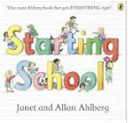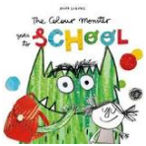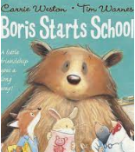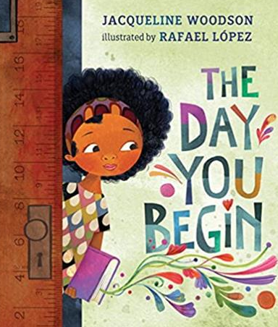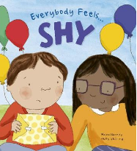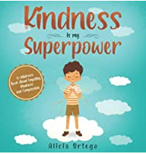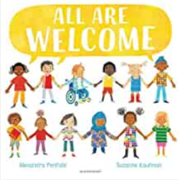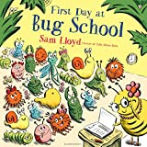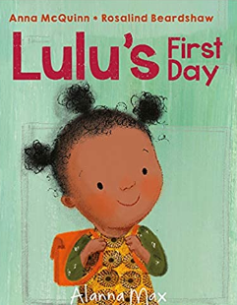  Manage behaviour:  Can inhibit own actions, welcome distractions when upset.  Understand behavioural expectations of St Thomas More CVA  Know that following rules is important  Self-awareness:  Know what they like and do not like.  Know that there are rules in the classroom to follow and expectations for behaviour.  Independence:  Know how to organise themselves in the morning e.g., bookbag in tray, coat on peg, water bottle on trolley, name card on board.  Know how to manage their own personal hygiene e.g., toileting. Can follow 1 step instructions.  Collaboration:  Know that if work together to keep the class rules and earn positive rewards.  Social skills:  Know how to engage in positive interactions with adults and peers.  Play with one or more children, extending and elaborating play ideas.  TEN:TEN  Reception - Mrs O’Brien  Me, My Body, My Health  - Know that we are each unique, with individual gifts, talents and skills  - Know that we all have similarities because we are made in God’s image, difference is part of God’s plan!  Reception/Year 1 – Mrs Whitehead  Think Positive KS1  Think Happy, Feel Happy It’s Your Choice, Go-Getters, Let It Out, Be Thankful, Be Mindful | Continue to develop skills of using gestures, non-verbal communication, facial expressions, body language, appropriate language, and vocabulary; to listen to others, speak to peers and adults and engage in discussions in a positive way.  Introduction of zones of regulation
Physical  Development |  | Know the routines of the school day: lining up and queuing, mealtimes, personal hygiene, carpet spots.  Develop their small motor skills so that they can use a range of tools competently, safely, and confidently. Suggested tools: pencils for drawing and writing, paintbrushes, scissors, knives, forks, and spoon.
 |  | REAL PE FOCUS  Reception – Mrs O’Brien  Gymnastics – Big Moves  Reception/Year 1 – Mrs Whitehead  Brilliant Ball Skills | Continue to develop the overall body strength, co-ordination, balance, and agility needed to engage successfully with future physical education sessions and other physical disciplines including dance, gymnastics, sport, and swimming.
Literacy |  | COMPREHENSION  Listen and enjoy sharing a range of books.  Know how to hold a book correctly, handle with care.  Know that a book has a beginning, an end.  Know how to hold the book the right way up and turn some pages appropriately.  Know that text in English is read top to bottom and left to right.  Know the difference between text and illustrations.  Know how to recognise some familiar words in print, e.g., own name or advertising logos.  Know that illustrations help to understand what is happening in a story.  Know familiar rhymes, stories or poems and complete a repeated refrain. | Enjoy joining in with rhyme, songs, and poems.
 |  | WORD READING  Hear general sound discrimination and be able to orally blend and segment. | Re-read books to build up their confidence in word reading, their fluency and their understanding and enjoyment. Read books consistent with their phonic knowledge.
 |  | WRITING  Emergent writing:  Know that writing communicates meaning.  Know that marks can have meaning.  Know how to write their name by copying it from a name card or try to write it from memory.  Composition:  Know that ideas for stories can be written down.  Use talk to link ideas, clarify thinking and feelings.  Spelling:  Know how to orally segment sounds in simple words.  Know how to write their name copying it from a name card or try to write it from memory.  Handwriting:  Know that print carries meaning and in English, is read from left to right and top to bottom.  Know how to draw lines and circles. | Develop listening and speaking skills in a range of contexts.
Phonics |  | Baseline – 3 weeks  Hear general sound discrimination, identify rhythm, rhyme, alliteration and be able to orally blend and segment simple words.  Little Wandle - Phase 2  Phase 2 graphemes – s, a, t, p, I, n, m, d, g, o, c, k, ck, e, u, r, h, b, f & l  Tricky words – is, I & the | Continue to develop general sound discrimination, rhythm and rhyme, alliteration, voice sounds, oral blending, and segmenting.
Mathematics |  | 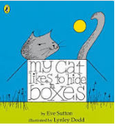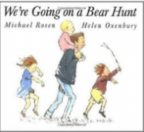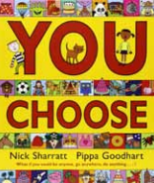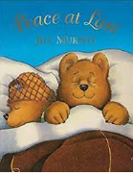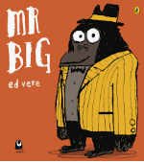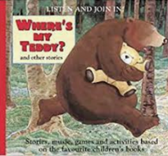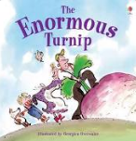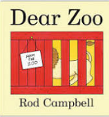  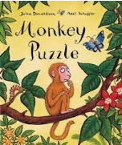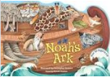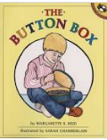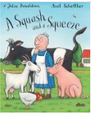
Baseline – 3 weeks
Opportunity to settle in, intro the areas of provision inside and outside and get to know the children’s mathematical knowledge through play, intro key times of day, class routines, where do things belong? Positional language
 |  | White Rose – Just Like Me  Count objects  Counting by rote, counting aloud, clapping, stamping, drumming etc, nursery rhymes, counting songs, using fingers to represent numbers | Encourage chn to put objects into a line so they have a clear start and end point, actions, and sounds.
 |  | Subitise – perceptual subitizing | Start by subitising and counting objects that are identical before moving on to slight differences e.g., size/colour, 5 frames can be used to support chn to subitise and compare numbers within 5.
 |  | Matching and Sorting into groups same/different, colour, size, shape. | Show collections of objects can be sorted into sets based on attributes such as colour, size, or shape. Understand the same collection can be sorted in different ways, discover own criteria.  Lining up time sorting – if you like carrots line up, if you have a sister line up
 |  | Comparing amounts – equal, more than, fewer than. | Understand when making comparisons a set can have more items, fewer items or the same as another set. It is easier to make comparisons when the difference between sets is greater
 |  | Comparing size, mass & capacity – big/little, large/small, short/tall, tallest/shortest. | Specific language introduced such as tall, short, and long. Encourage using specific vocab to describe what they notice
 |  | Exploring pattern - making simple patterns, odd one out, exploring more complex patterns. | Copy, continue and create own simple repeating patterns. Provide patterns with at least 3 full units of repeat. Say the pattern aloud to help to identify the part which repeats and supports to continue. AB patterns in a range of contexts e.g., shapes, size, actions, sounds. Build patterns vertically and horizontally.
Understanding the World  Religious Education  Come and See |  | Talk about members of their immediate family and the relationship to them, name and describe people who are familiar to them.  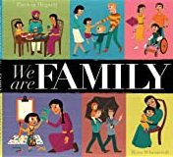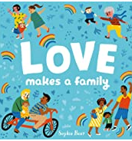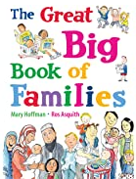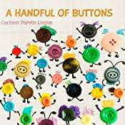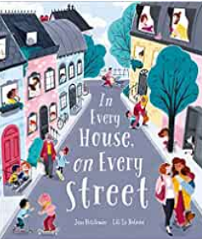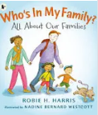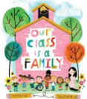  Chronology:  Know the members of their immediate family and the relationship to them, name and describe people who are familiar to them.  Know that you can find out information from different sources e.g., internet, books.  Know and talk about the special things in their own lives. Know how to respect and take care of school resources.  Know how to show respect and care for the natural environment and all living things.  Know that families in other countries across the world engage in similar activities to their own family. Know some differences.  Know that features of their immediate environment can be represented with objects and on paper e.g., classroom maps, Pete’s story map around school, seating maps, nature area map.  Know common signs and logos.  Know that the environment where they live can change through the seasons. Describe what they see, hear, and feel outside.  Explore the natural world around them.  Reception– Mrs O’Brien  Myself  To develop understanding of first and family names. Know that God knows and loves each one of us and that he knows each person’s name.  Know that God loves each person.  Reception/ YEAR 1 – Mrs Whitehead  Families  Why do we have a family and who is my family?  Belonging What does it mean to belong? | Communication: Comment on what they notice about the environment where they live and understand the effect of the changing seasons on the natural world around them. Describe what they see, hear, and feel outside.  Observation: Explore the natural world around them and make observations and drawing pictures of animals and plants. Understand the need to respect and care for the natural environment and all living things.
Expressive Arts and Design |  | Develop storylines in their pretend play.  Mark Making/Drawing:  Know how to grip a pencil comfortably and make marks, create lines and circles. Know that marks can have meaning. Create a self-portrait.  Colour:  Know the names of light colours and dark colours.  Know how colours can be changed using light and dark colours.  Painting:  Artist study – Know that Jackson Pollock created splatter  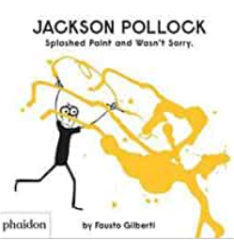  painting.  Know how to collaborate with others to create artwork.  Printing:  Know how to print using hands, feet, and fingers.  Materials:  Know that materials can feel different. Know some words to describe materials.  3D Work:  Know what transient art is. (Transient art will continued to be offered in continuous provision throughout the year)  Cutting Skills:  Know how to safely pass scissors to another person.  Know how to use scissors to make snips in paper.  Kapow - Exploring Sound | Explore, use, and refine a variety of artistic effects to express their ideas and feelings.  Take part in simple, pretend play often based on familiar experiences, e.g., making dinner.  Uses available resources to create props or creates imaginary ones to support play.  Develop storylines through small-world or role-play

